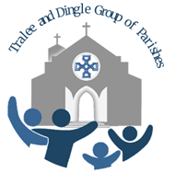

A Liturgical welcome to Kerry
for
The Right Rev Michael Burrows
Bishop of Tuam, Limerick and Killaloe.

Saturday 11th June 2022 @7pm
The Feast of St Barnabas

The Church of St John The Evangelist Tralee

